Weimar Independent School District Comprehensive School Counseling Plan

2023-2024
Counselor Advisor Team includes:
Lindsay Fisbeck-District Counselor
Skye Anderle-Weimar Junior High Principal
Codi Pesak-Junior High Counselor
Stacy Heger-High School Principal
Kristy Janecka-Elementary Principal
Amy Streit-High School English teacher
Amanda Turlington- Special Education Director Stephanie Bludau-LSSP
Leslie Kloesel-District Nurse

Weimar Elementary Weimar Junior High Weimar High School

Weimar ISD Mission Statement for the School Counseling Program

The goal of the Weimar Independent School District counseling program is to prepare all students socially, academically, and mentally, and emotionally for present and future challenges. Students have the opportunity to participate in educational and career exploration, and to pursue career planning opportunities in a safe, nurturing, and encouraging environment. As counselors, we will work in a collaborative partnership with students, parents, teachers, and community members to empower students to reach their highest potential. Together with our stakeholders, our tiered approach incorporates direct and indirect services that ensure equity and access for every student in order to help them become future leaders and contributors to a global society with 21st century skills.

- The Texas Model for Comprehensive School Counseling Programs in Texas public schools are an integral part of the total educational program. Through a systematic and planned program, school counselors apply specialized knowledge and skills to provide developmentally appropriate support and interventions for all students. The Texas Education Code (§33.005) specifies that “a school counselor shall work with the school faculty and staff, students, parents, and the community to plan, implement, and evaluate a developmental guidance and counseling program.” Furthermore, the school counselor shall design the school counseling program to include the following four components:

- 1. Guidance Curriculum “to help students develop their full educational potential, including the student's interests and career objectives;”
- 2. Responsive Services “to intervene on behalf of any student whose immediate personal concerns or problems put the student's continued educational, career, personal, or social development at risk;”
- 3. Individual Planning “to guide a student as the student plans, monitors, and manages the student’s own educational, career, personal, and social development;”
- 4. System Support “to support the efforts of teachers, staff, parents, and other members of the community in promoting the educational, career, personal, and social development of students.”

- 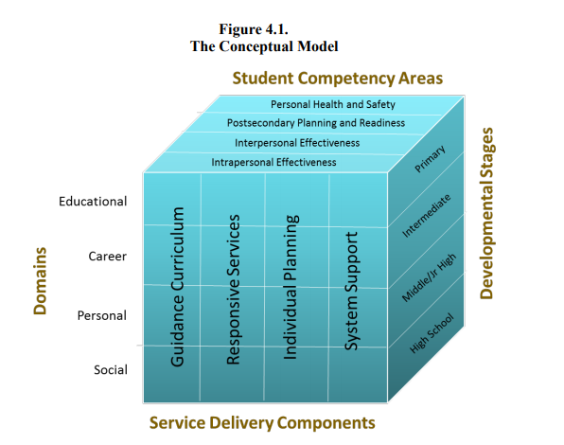
- Brief Description of Service Delivery Components and Program Definition; Defining Elements of the CSCP

Guidance Curriculum. The guidance curriculum is designed to systematically provide lessons to students that facilitate growth, development, and transferable skills in the areas of educational, career, personal, and social development. The need for students to become advanced critical thinkers, efficient problem solvers, and demonstrate appropriate behavior and disposition offers justification for a guidance curriculum. The guidance curriculum can be taught in units through differentiated learning activities in the classroom with planned lessons for various sized groups of students at all grade levels.

Responsive Services. The purpose of responsive services is to support students and offer support in their time of need. Similarly, responsive services can have the three levels of school counselor response, those of prevention, remediation, and crisis, to needed or critical situations.
Prevention refers to the work of school counselors to ensure all students are educated and knowledgeable of competencies necessary to address troublesome circumstances before they become habitually problematic. Preventive measures help reduce or eliminate the likelihood of those situations occurring again.
Remediation is a necessary school counselor action once a challenging situation has taken place and the student needs assistance in resolving the problem. During a crisis, the school 79 ­ counselor intercedes immediately in high risk situations that may greatly impact the student’s personal, social, academic, or career development.
Crisis response may have local processes and procedures that structure immediate action, and confirmation of those actions may include communication and collaboration with campus and district level administrators.
Responsive services may also include consultation with teachers, parents, and others who can assist the student with problematic issues. Additionally, referral to community services outside the school may be considered. At all levels of intervention, school counselors reflect and consult as needed to change or refine processes relevant to each situation.

Individual Planning. The purpose of individual planning is to assist students in developing and addressing academic, career, personal, and social goals. Students need opportunities to understand and monitor their own development considering their individual needs, specialized circumstances or services, and cultural implications. In delivering individual planning services, school counselors use knowledge, the ability to integrate district and state requirements, and student preferences to assist students in developing realistic and attainable goals.

System Support. System support is essential to the total school counseling program. System support can be categorized in two areas: program management activities and support services. Program management activities establish, maintain, and enhance the total school counseling program. Through this indirect service component, school counselors plan, organize, implement, manage, and evaluate their school counseling programs to increase the efficiency and efficacy of direct services that are provided.
System support is the foundation of the school counseling program. Without system support, the three direct service delivery components might be a collection of disorganized and ineffective services. Support services include indirect services to students through school counselor relationships with other adults as well as campus, district, and community programs and services that can be beneficial to students. Through school counselors’ coordinated and consultative efforts, the strengths and resources of these individuals and entities are harnessed on behalf of students’ educational, career, personal, and social development.

1.Guidance & Counseling Curriculum and Information
- The mission of the Guidance, Counseling, and College Readiness areas is to implement a comprehensive developmental guidance and counseling program in grades PreK-12 that promotes student success through a focus on academic achievement, prevention and intervention activities, advocacy and social/emotional and career development to meet the needs of the students.
- The comprehensive developmental guidance and counseling program model is embedded into the Weimar ISD academic curriculum and covers these strands:
  - Self-knowledge and acceptance
  - Interpersonal and communication skills
  - Responsible behavior
  - Conflict resolution
  - Decision making/problem solving
  - Motivation to achieve/Study Skills
  - Goal setting
  - Career planning and Awareness
  - Peer Relationships
  - Substance Abuse Programs
  - Personal Safety
  - Self Esteem and Body Image

In Texas, four strategic curricular content areas have been identified for the Guidance Curriculum:

Intrapersonal Effectiveness | - Positive student self-concept  - Effective executive functioning skills  - Appropriate behavior to the situation and environment
Interpersonal Effectiveness | - Effective interactions with diverse populations  - Effective and appropriate communication skills  - Recognition of personal boundaries, individual rights and privacy needs of others  - Effective conflict resolution skills  - Development of healthy relationships
Post-Secondary Education and Career Readiness | - Motivation to succeed in personal endeavors  - Demonstration of career exploration skills  - Possession of the knowledge and skills to gather information for the purpose of postsecondary education and career planning  - Demonstration of awareness of the importance of postsecondary education  - Understanding of the relationship of academics to the world of work and to life at home and in the community
Personal Health and Safety | - Incorporation of wellness practices into daily living  - Demonstration of resilience and positive coping skills  - Possession of assertiveness skills necessary for personal protection

Specific Guidance Curriculum activities at Weimar ISD (Elementary, Junior High, High School)
- At Weimar Elementary School, Manners of the Heart is a respect-based Heart Health and Character Education/Social Emotional Learning Curriculum that assists children in developing necessary skills to stay in school, perform better in school, maintain healthy relationships and develop better problem solving skills. All students get weekly guidance lessons to assist with the implementation of this program.

- Positive Character Traits Education shall integrate positive character traits into the essential knowledge and skills adopted for kindergarten through 12th grade. The following traits are incorporated into embedded guidance lessons as well as lunch sessions, and personal visits with students:
*Courage
*Trustworthiness, honesty, reliability, punctuality, and loyalty
*Integrity
*Respect and Courtesy
*Responsibility, including accountability, diligence, perseverance, and self-control
*Fairness
*Caring, kindness, empathy, compassion for others, consideration, charity
*Good Citizenship, Patriotism, Respect for Community and the Common Good
*School Pride
*Gratitude

2.Individual Planning and Services
Weimar ISD provides counseling activities to assist all students to plan, monitor, and manage their own academic achievement as well as their personal and career development.
Weimar ISD provides the following counseling services to our students:
- Individual Planning
- Small Group Counseling
- Classroom Guidance
- Crisis Counseling
- Academic, Career, and College Planning
Issues that can be addressed during Individual Planning:
- Personal and Social Issues
- Development of healthy self-concept and self-image
- Development of both short and long term goals both personally and academically
- Mental Health
- Academic
- Study Skills
- Educational Opportunities
- Lifelong learning goals-what does it mean to graduate from high school then pursue higher educational goals
- Utilization of test scores and data-TSI,SAT, STAAR, EOC
- Weimar ISD Course Guide Weimar ISD Course Guide (Update)
- 4 year plans
- Dual Credit Planning
- Testing Services
- Career
- Knowledge of career opportunities and career planning using XELLO
- Occupational training
- Development of an education/career plan
- ACCSS Grant CTE classes offered at Weimar High School-CNA, Medical Terminology, Welding, Education classes

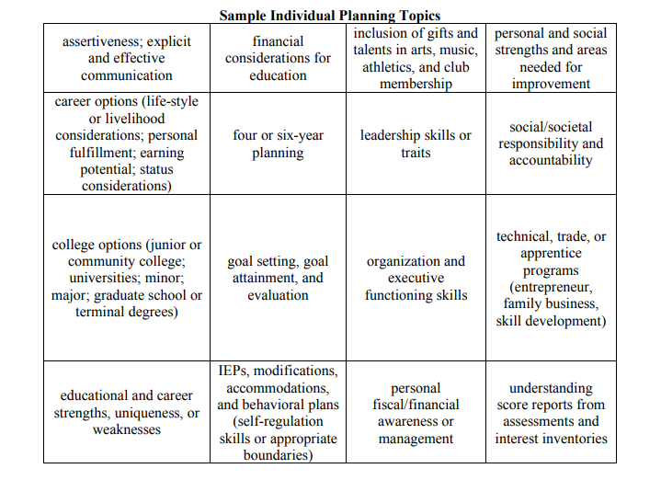
Weimar ISD Individual Planning Topics (College and Career/Mental Health/Character Traits):
- Meet the Teacher and Parent Meetings such as Open House in the spring
- College and Career Fairs
- Apply Texas Luncheons
- Blinn College FAFSA Night
- Mobile Blinn Bus
- Individual Scheduling Meetings discussing Four-Year Plans-8th grade-12th grade
- College Visits and College Awareness (Pre-K through 12)
- XELLO Career Planning
- Personal Graduation Plan meetings
- Gifted and Talented Project Planning
- SAT School Day/ACT School Day
- TSI Testing
- ARD/504 Meetings
- ASVAB Career Planning/Post Testing Presentation
- Monthly class meetings
- Mental Health Lunch Sessions-detailed agenda included
- Small Group Character Building Sessions
We also incorporate Anger Management, Dealing with change in the home and family, Getting along with friends or difficulty making friends, Teasing, bullying, sexting, cyberbullying, Handling stress healthfully, Human Trafficking, and Prom Safety.

Helpful College/Career Planning Websites:
Advisor Toolkit - SCHOLAR
Apply Texas Instructions: https://sites.google.com/a/esc12.net/escscholar/college-and-career-readiness/apply-texas-how-to
BigFuture | Find the Best College for You
Pay for College | Selecting a Financial Aid Package
College For All Texans: Home
Apply for Financial Aid
GenTX
What Should I Major in? Create your college and career plan
Career and Technical Education | Texas Career and Technical Education
http://assessment.texasgenuine.org/
THECB: Home
CareerOneStop: Careers and Career Information
SAT VOCAB-http://vocabahead.com/

3.Responsive Services
Weimar ISD has services that include counseling or referral activities that meet the immediate needs and concerns of students. Responsive services include personal counseling, crisis counseling, problem solving, agency referral, and consultation. In responsive services the school counselor responds effectively to problematic or critical incidents to support students and offer services in their time of need. School counselors are highly qualified to meet the immediate needs of students. Societal and school climate changes influence student development. Therefore, a school counselor must be capable of providing responsive services at the preventive, remedial, and crisis levels (Gysbers and Henderson, 2012)

Consultation: School counselors serve as student advocates by consulting with students, parents or guardians, educators, and community agencies regarding strategies to help students and families. Advocacy may include participation in student study teams and student management teams.

Personal Counseling: Counseling is provided in small-group or individual settings for students experiencing difficulties dealing with relationships, personal concerns, or developmentally appropriate tasks. Personal counseling assists students in identifying problems, causes, alternatives, and consequences leading to informed decision making.

Crisis Counseling: Counseling and support services are provided to students and families facing emotional crises as outlined in the school crisis management plan. Crisis counseling is normally short-term and temporary, using appropriate referral sources if necessary such as referrals to Texana or the Family Crisis Center.

Click on Links Below to visit informational websites for free resources: In addition to the following resources, please visit the Weimar ISD website, click Parents and Students, and click which resources you are interested in. If you click the Report Bullying tab, click the anonymous report, and you are redirected to the Report Bullying page as well as resources such as Youth and Family Services, and Texas Project First.

Texana - Home 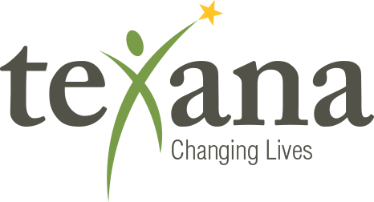

https://suicidepreventionlifeline.org/

Suicide Prevention Resource Center-Suicide Prevention and Crisis Help Line

Family Crisis Center (Bastrop)
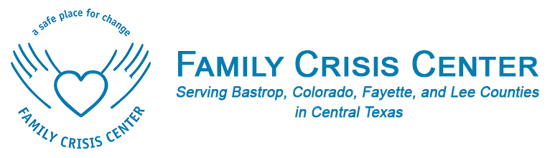

StopBullying.gov-Bully Prevention and Crisis HotLine-1-800-273-TALK and the Crisis Text Line-Text TX to 741741

Bigger Than Bullies: Home

https://www.d2l.org/

Recognizing the Signs of Human Trafficking in Schools: A Guide for Texas Educators

TEHCY Support Center: Home
Anonymous Bully Reporting Technology For K-12 Schools | Cyb…

Mental Health & Substance Use

TCHATT Resource-https://tcmhcc.utsystem.edu/tchatt/
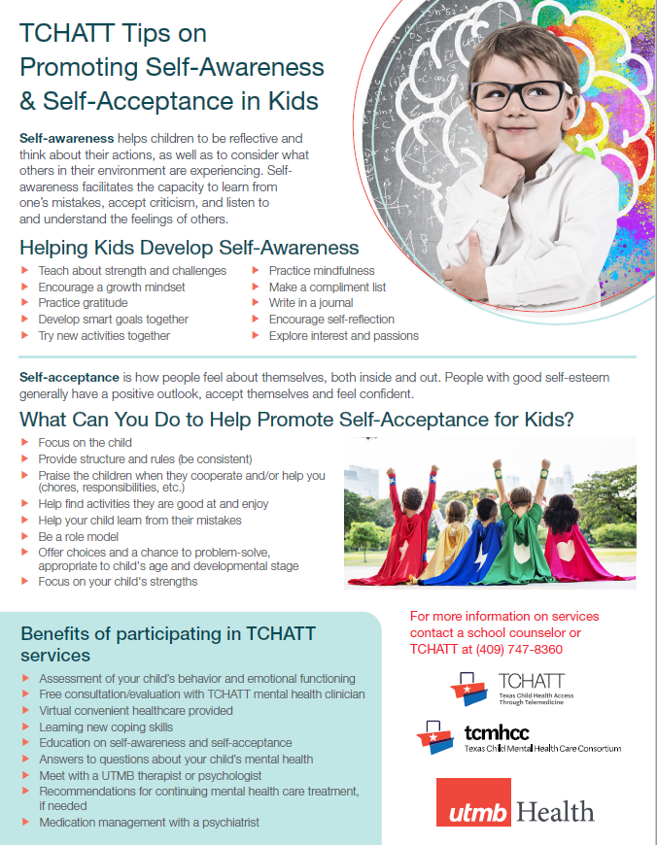

Threat Assessment at Weimar ISD

Weimar ISD has incorporated a threat assessment team. The threat assessment team is a group of officials that convene to identify, evaluate, and address threats or potential threats to school security. Threat assessment teams review incidents of threatening behavior by students (current and former), parents, school employees, or other individuals. Some schools may need assistance in determining whether a health or safety emergency exists in order to know whether a disclosure may be made under FERPA’s health or safety emergency provision. Accordingly, members of a threat assessment team might include officials who can assist in making such decisions, such as school principals, counselors, school law enforcement officials, as well as outside medical and mental health professionals and mental health law enforcement officers.

Weimar ISD Threat Assessment Team
Jon Wunderlich-Superintendent | Stephanie Bludau-LSSP | Amanda Turlington-Special Education Director
Stacy Heger-High School Principal | Kristy Janecka-Elementary Principal | Angela Weid- Elementary Counselor
Lindsay Fisbeck-High School Counselor | Skye Anderle-Elementary Principal | Codi Pesak-Junior High Counselor

Several topics have been identified as high priority issues at the state and local levels. Weimar ISD works with students, staff, parents, and the community to identify priorities where students will be served through the responsive services component. The following list provides examples of topics that have been identified for service provision through the responsive services.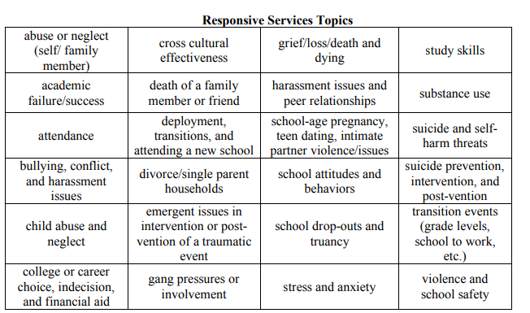
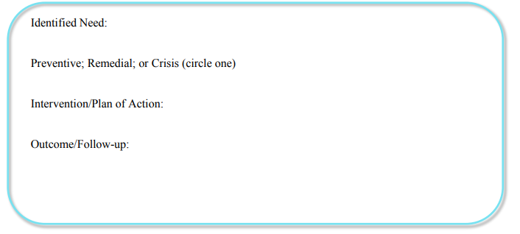
Weimar ISD Counselors take all of the above topics seriously and take all necessary steps to help and serve our students what is in their best interest.

**** Weimar ISD Crisis Management Plan available upon request.

Weimar ISD Program Goals and Process:
Needs Assessment Results:

Suggestions include:
Getting along with friends | Teasing, Bullying, Cyberbullying | Dealing with change/new situations at home with family
Handling stress | Anger Management | Study Skills
Improving Grades | Suicide Ideations | Anxiety/Panic Attacks

Data will be reviewed from:
Group Data, Staff Evaluations, Student Assessment Needs, Discipline Referrals, Failure Reports

End of Year Data/Patterns will be collected and inserted at the end of this year.

4. System Support
Weimar ISD’s system support includes indirect guidance management activities that maintain and enhance the total counseling and guidance program. Responsibilities in this area include staff relations, community relations, task forces, professional development, support teams, test interpretation, data analysis, and curriculum development. This component provides appropriate support to academic programs.

Professional Development: The counselor is regularly involved in updating professional knowledge and skills. This may involve participating in regular school in-service training, attending professional meetings, completing postgraduate course work, and contributing to professional journals.

In-Service: The counselor attends system and school in-service training to ensure counseling skills are updated in the areas of curriculum development, technology, and data analysis. The counselor may provide in-service instruction in school guidance curriculum and areas of special concern to the school and community.

Consultation, Collaboration, and Teaming: The counselor provides important contributions to the school system by consulting, partnering, collaborating, and teaming.

Public Relations: The counselor designs activities to orient the staff and community about the comprehensive school counseling and guidance program.

Community Outreach: Counselors forge partnerships with local businesses, industries, and social service agencies. Community outreach requires counselors to be knowledgeable about community resources, employment opportunities, and local labor market information. Community involvement includes Stanzel, Boys and Girls Club, Weimar Public Library, Weimar Chamber of Commerce, Weimar Parents as Teachers, Weimar Rotary Club, and Weimar Lions Club.

Consultation with Staff: The counselor consults regularly with teachers and professional staff members in order to receive feedback on emerging needs of students and to provide information and support to staff.

Curriculum Development Support: The counselor participates in the ongoing review and revision of academic curriculum materials as related to data analysis, student advocacy, postsecondary education, and career/technical education planning. (Site-Based Committees, District and Campus Improvement Plans)

Advisory Committees: The counselor forms and participates in counseling and guidance advisory committees at both the system and the individual school level. The counselor actively serves on community committees or advisory councils that influence other programs to generate support for system and individual school counseling and guidance programs. (PTO, PTA)

Program Management and Operations: Planning and management tasks include the support of activities conducted in the school counseling and guidance program and responsibilities expected of a member of the school staff. Budget, facilities, policies and procedures, and research and resource development are elements of management activities.

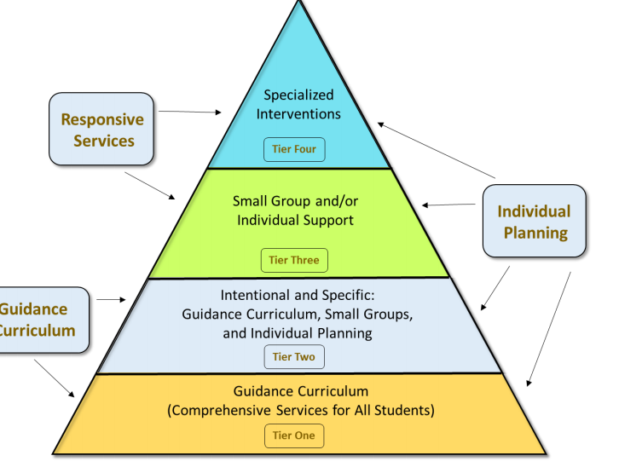
School Counselor Competencies:
- Program Management
- Advocacy
- Guidance (theories, plan lessons, groups, involve others)
- Professional Standards (ethics)
- Professional Behavior (relationships, use of time)
- Consultation
- Coordination
- Leadership
- Counseling (Intervention for students personal/social development, individual/group counseling)
- Student Assessment

Counselor Time/Program Component

 | WES | WJH | WHS
Guidance Curriculum | 35%-45% | 35%-45% | 15-25%
Individual Planning | 5%-10% | 15%-25% | 25%-35
System Support | 10%-15% | 10%-15% | 15%-20%
Responsive Services | 30%-40% | 30%-40% | 25%-35%

Program Goals for Weimar Elementary and Weimar Junior High for the 2022-2023 School Year:
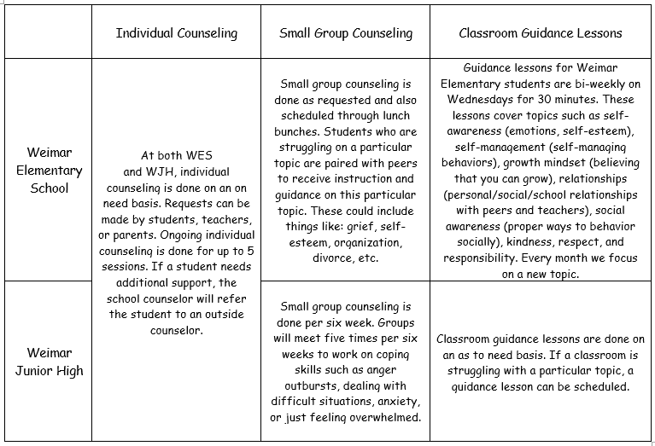
Weimar Junior High Program Goals
Classroom guidance lessons are done once a month. Topics covered are the 12 Positive Character Traits that are assigned to each month. If a classroom is struggling with a particular topic, a guidance lesson is scheduled. All grade levels complete Growth Mindset Bell Ringers each day in the general education classrooms.

SMART Goal 1
By the end of the school year, 90% of all junior high students will be able to list two ways they can improve their overall academic achievement.
SMART Goal 2
By the end of the school year, 90% of all junior high students will identify two ways they are able to use coping skills for stress management and/or conflict resolution.
SMART Goal 3
In Career Investigation class, 8th grade students will learn about different career pathways and 90% of students will choose a high school graduation pathway that best aligns with their post-secondary career interests.

Program Goals for Weimar High School

Weimar High School | Individual Counseling-  Scheduled anytime during the school day | Small Group Counseling-  Monthly  Lunch Sessions  10:20-10:40 | Classroom Guidance Lessons-  Integrated in Professional Communications/AFNR/Govt/  Economics
September | Individual sessions are as needed. | College Applications-  Where do I begin?FAFSA Forms  Handling the stress of the upcoming year | Youtube Video/Guidance Lesson/  Discussion each month on the following:  Courage and Integrity
October | Individual sessions are as needed. | TSIA/SAT/  Khan Academy Review/ASVAB | Trustworthiness  Honesty
November | Individual sessions are as needed. | How to manage stress and anxiety?  Study Skills and Problem Solving | Respect and  Courtesy
December | Individual sessions are as needed. | Self-Esteem and Developing your growth mindset-How to gear your mind to think about your future?  Grades, Career, Life in general | Fairness  Justice and Freedom  Accountability  Perseverance  Charity  Patience
January | Individual sessions are as needed. | Peer Relations and Social Skills/Vaping and our Youth  Responsible Behavior with Social Media | Good Citizenship  Patriotism  Respect for Authority and the Law
February | Individual sessions are as needed. | Scholarship Meeting-  Common Application/ | School Pride  Reliability
March | Individual sessions are as needed. | Scholarship Meeting | Gratitude
April | Individual sessions are as needed. | Motivation to Achieve-Guest Speaker | Loyalty  Generosity  Consideration
May | Individual sessions are as needed. | Motivation to Achieve-Guest Speaker | Kindness  Empathy  Compassion

WJH Guidance Lessons
August-School Pride
September-Respect & Courtesy
October- Responsibility
November- Gratitude
December- Caring & Compassion
January- Courage
February- Fairness & Freedom from Prejudice
March-Honesty & Integrity
April- Perseverance
May- Citizenship & Patriotism

Small Groups
Stress/Anxiety
Emotional Regulation
Self-Esteem
Loss/Grief
Making Friends

Weimar High School
Monthly Career/College and Information Sessions
Group Sessions

CURRENTLY UPDATING!!!! AS OF 9/28/2023
Topic | Month | Presenter | Monthly Self-Care Discussion Board-  Group and Individual Sessions
Blinn Dual Credit Meeting |  | Shannon Loukanis  ACCSS Sarah Nickel | Understanding the Blinn process
Time Management and Understanding My stress and Anxiety |  | Lindsay Fisbeck | Group Session
Apply Texas Luncheon |  | Lindsay Fisbeck and Sarah Nickel
ASVAB Testing |  | Darryl Miller/Military Center
Suicide Prevention |  | Lindsay Fisbeck | Suicide and Crisis Lifeline Dial 988
Friendship Goals  How to be a better friend? How do I get more involved to make friends? |  | Lindsay Fisbeck | Group Session
FAFSA Opens!!! |  | Lindsay Fisbeck | FAFSA paperwork
FAFSA DAY!!!!! |  | FAFSA Applications are open!  Students will use their Government class to begin this process.
SAT School Day |  | WHS Gym/Lindsay Fisbeck
College Visit from Wharton County Junior College |  | Wharton County Junior College Presenters | During activity period, WCJC will go over their Academic and Career programs such as welding, HVAC, Radiology, and Dental Hygiene
College and Career Night-Evening (Optional) |  | La Grange High School | Transportation provided
PSAT School Day for 10th graders |  | WHS Gym/Lindsay Fisbeck
PSAT School Day for 8th Graders |  | WHS Gym/Lindsay Fisbeck/Codi Pesak
College and Career Fair-Columbus High School |  | CHS Gym/Lindsay Fisbeck | Bus transportation-  Lindsay Fisbeck  Misty Mican
Respect? How do I give it? How do I earn it? Respect each other and Respect yourself! |  | Lindsay Fisbeck | Group Session
ACT School Day |  | WHS Gym/Lindsay Fisbeck
PSAT School Day for 9th graders |  | WHS Gym/Lindsay Fisbeck
FAFSA and Blinn Information |  | Blinn presenters-Seniors only (3rd period and during activity period)
College Visit |  | Sam Houston State University Campus Group Tour | Bus Transportation and Teachers:  Lindsay Fisbeck  Hunter Ervin  Misty Mican
LCRA Presentation |  | Tonell Broaders  WHS Library/Activity period | LCRA Headquarters will be here to discuss the various fields and job opportunities within LCRA. They will discuss a wide range of jobs including those that are college bound, trade school bound, as well as those that want to join the workforce.
Gratitude and Giving |  | Lindsay Fisbeck | Group Session-Vist to local nursing home
College Visit |  | Texas A&M University College Campus and Residential Hall Tour | Bus Transportation and Teachers:  Lindsay Fisbeck  Anne Douglas  Stacy Heger
New Year-New You-How to start your year with positivity and Energy! |  | Lindsay Fisbeck-Guest Speaker | Group Session
College Visit to WHS |  | TSTC
Crime Stoppers Presentation |  | Prom Safety  Human Trafficking  Situational Awareness | Group Session for month of February
Credits For Life |  | WHS Gym/Women’s Christian Academy/Mrs. Chernis
Citizenship-How do I earn it? How can I be a good citizen in my school and community? |  | Guest Speaker-Lions Club | Group Session
Medical Field Specialist from the Tri-County Area

Character Trait Review…Year Review and What I can do next year…explore new topics, new ideas… |  | Lindsay Fisbeck | Group Session
WHS Annual Job Fair
Game Warden/Law Enforcement/  Criminal Justice Presentation |  |  | Character
Welding/Plumbing/  Construction Presentation |  |  | Character

